3.27: Take 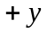 to be upward.
Use the vertical motion to find the time it takes the suitcase to reach the ground:
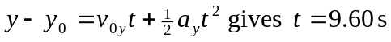

The distance the suitcase travels horizontally is 